OBJECTIVE

To create Café management system which enables the user to do the following:

1. Take Order
2. Amount calculation
3. Print Bill
4. Add to menu
5. Modify menu
6. Delete from menu
7. Search a given item

HEADER FILES USED

#include<iostream.h>

#include<conio.h>

#include<stdio.h>

#include<fstream.h>

#include<string.h>

#include<process.h>

CLASSES AND RELATED FUNCTIONS

Class: menu

This class is used as a base class for menu and has functions which enables various operations based on menu.

The functions in this class are:

getdata: This function is used to get data from user for the main menu.

putdat : This function is used to show data on screen for the main menu.

agetdata: This function is used to get data from user for the addons menu.

aputdat : This function is used to show data on screen for the addons menu.

getcode: This function is used to return the item code for main menu.

getacode: This function is used to return the item code for addons menu.

getprice: This function is used to return the item price for main menu.

getaprice: This function is used to return the item price for addons menu.

Class: order

This class is used as a base class for order and has functions inside it which enables various operations on taking order from customers.

The functions in this class are:

order (constructor): This function is used to initialize values.

mainorder: This function is used to get the main order and add and return the value if the sum of the prices of the items.

addons: This function is used to get the addons order and add and return the value if the sum of the prices of the items.

Class: invoice

This class is used as a derived class for order and has functions inside it which enables various operations on calculating tax and amount order.

The function in this class is:

Invoice (constructor): This function is used to initialize values.

print: This function is used to calculate values of prices of main order and addons, calculate VAT and the grand total.

Class: emp

This class is used as a invoice class for order and has functions inside it which enables various operations on displaying data.

The function in this class is:

employee: This function is used inherit the values of items, prices, etc.,

to print the bill.

INDEPENDENT FUNCTIONS

login: This function takes the username and password and grants permission to the user to the program.

initialise: This function is used to give basic input to the file in case of an error or the data being lost.

add: This function is used to add an item in binary file to the main menu or the addons menu specified by the user.

modify: This function is used to modify an item of the file by taking data from the user.

del: This function is used to delete an item from the file by the item code specified by the user.

search: This function is used to display item details of an item by taking the item code.

ALGORITHM

Step 1: The user (management) should login into Café L’Amour account by using the user name and password.

Step 2 : The user is given 3 trials before the compiler displays the message “Login blocked.  Please contact Administrator. ”.

Step 3: If the login is successful the main menu is displayed.

Step 4: If option 1 is entered: The compiler asks the user to give the order given by the costumer.

Step 5: The compiler takes code number for the main order and asks weather there are any more items to be added.

Step 6: The same process is repeated for addons.

Step 7: The compiler then calculates the total, VAT and the grand total for the main order and the addons.

Step 8: The amount is then printed.

Step 9: If the option 2 is entered: The compiler asks to “Add to Menu”.

Step 10: In here 2 options are given: 1. “Add to the main menu”

                                                 2. “Add to addons menu.”

Where it asks the user to enter the details of the item to be added.

Step 11: If the option 3 is entered: The compiler asks to “Delete from Menu”. Where the compiler asks the item code to be deleted.

Step 12: If the option 4 is entered: The compiler asks to “Modify from Menu”. Where the compiler asks the item code to be modified and gets data.

Step 13: If the option 5 is entered: The compiler askes the item code that has to be searched and displays the details of the item.

Step 14: If the option 6 is entered: The program is ended.

OUTPUT

1)Login and choices

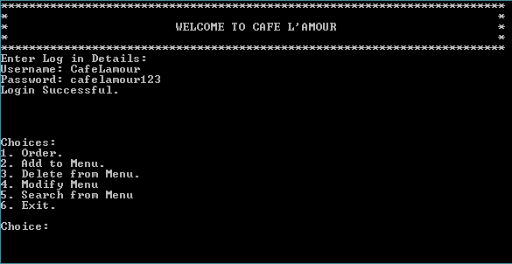

2)Order

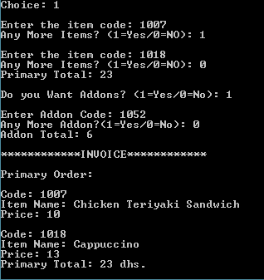

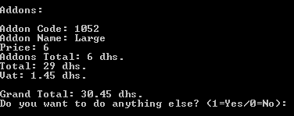

3)Add to main menu

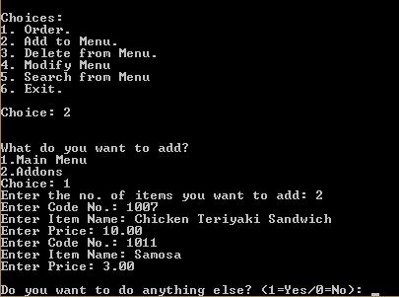

3)Add to addons menu

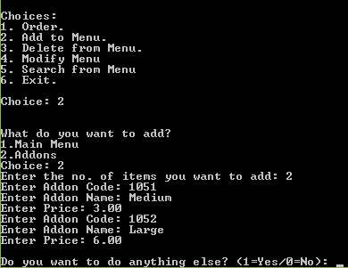

4)Delete from menu

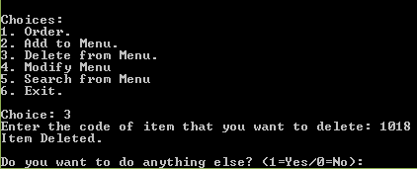

5)Modify menu

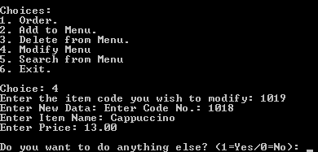

6)Search from menu

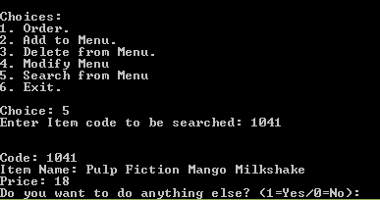

7)Exit

